Flood Recovery: Dealing with Continuing Basement Seepage

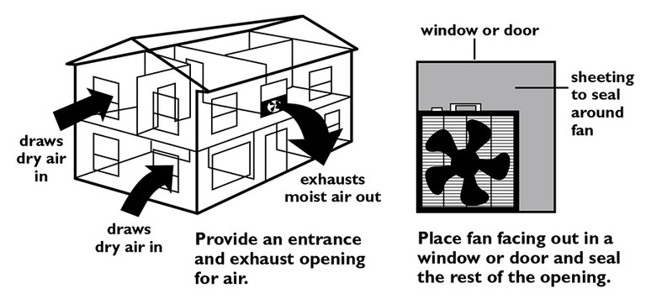
A water table above the basement floor causes water to continually seek ways to enter the basement. A drainage envelope created by drain tile or pipe in porous, granular material will intercept that water and direct it to a sump, where it can be pumped outdoors. Water will enter the basement at the connection between the wall and floor and through cracks in the floor if the drainage envelope does not exist or is not functioning. Sometimes water also will come through cracks in the wall, but generally that occurs due to water infiltrating the ground from above.

Mold growth, which is a health hazard, is a concern any time high humidity or damp materials exist. Wet or damp materials will mold in one to three days, depending on temperature. Mold spores, which are like mold “seeds,” are in the air everywhere, so the only method to prevent mold growth is to keep things dry or to remove them from the damp area. Remove porous materials such as cardboard boxes, papers, carpet, rugs and clothes to keep them from becoming moldy. Chlorine bleach is a biocide that will kill existing mold, but it does not prevent future mold growth. Mold must be removed, not just killed, to eliminate the health hazard.

Many wall coverings are porous and will not only absorb water but will wick the water above the water level. Gypsum board or drywall (Sheetrock) is very absorbent and will wick water up a wall. Remove or cut the gypsum board so none of it will be in the water. Mold grows readily on the paper of gypsum board, so controlling the humidity level in the basement is critical to minimize mold growth. Many paneling materials also are absorbent, so again cut the paneling to above the water level. If the water level is shallow, the wall can be repaired by using a tall baseboard.

Purchase a humidity gauge and keep the humidity below 70 percent. A dehumidifier will remove some water from the air. Ventilating with dry outdoor air also will reduce the humidity level. Providing both an opening for air to enter and exit is critical. Open at least two windows for cross-ventilation. Using a fan facing to the outdoors will assist with moving dry outside air through the basement. Use fans to circulate dry air across damp surfaces to help the material dry. Isolate the basement from the rest of the house to limit humidity from the basement entering the rest of the house.
Remove water from the basement by channeling the water to floor drains or by using a skimmer pump or wet vac. Water will continue to enter the basement as long as the water table is high, so the goal is to control the water flow rather than eliminate it. Generally, the water cannot be stopped from entering the basement with products placed inside the basement because of the external water pressure.

